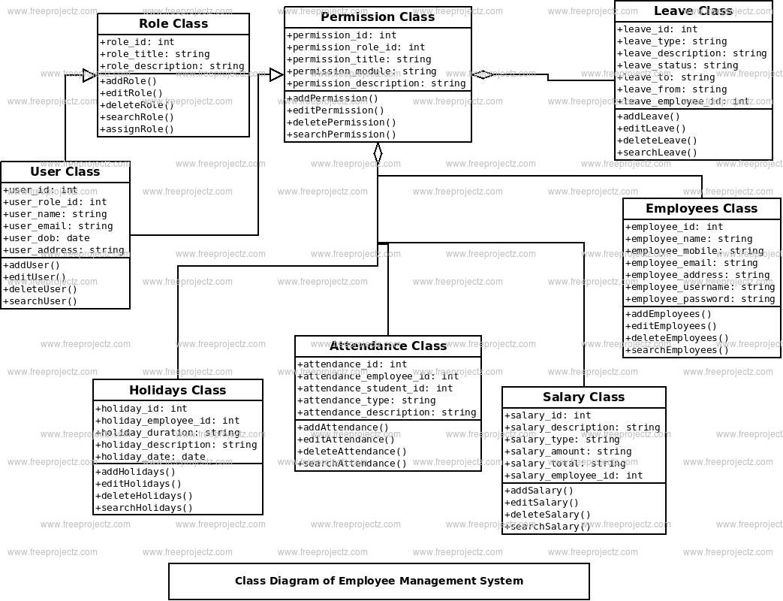https://www.google.com/imgres?imgurl=https%3A%2F%2Fi.ytimg.com%2Fvi%2FOL5jrg013qw%2Fmaxresdefault.jpg&tbnid=w3NcDAwYnSoPTM&vet=12ahUKEwjq27z88faAAxXCWmwGHV5kCLYQMygAegQIARBX..i&imgrefurl=https%3A%2F%2Fwww.youtube.com%2Fwatch%3Fv%3DOL5jrg013qw&docid=Fi8H8PHlHSf8HM&w=1280&h=720&q=uml%20diagram%20for%20employee%20management%20system&ved=2ahUKEwjq27z88faAAxXCWmwGHV5kCLYQMygAegQIARBX#imgrc=w3NcDAwYnSoPTM&imgdii=AfwCdfa8ppRSoM

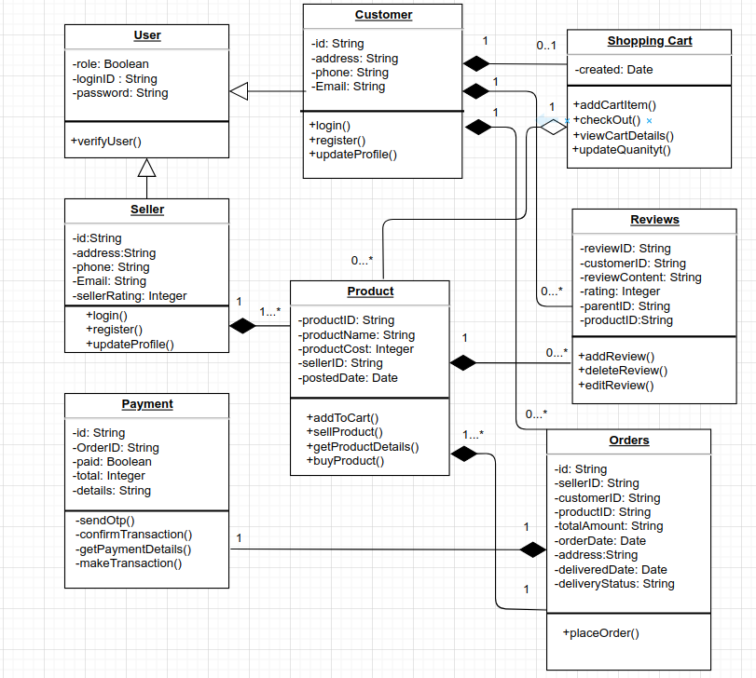

https://www.google.com/imgres?imgurl=https%3A%2F%2Flh4.googleusercontent.com%2F-i0Tuze5iHX-vta91r4tcFrnD_DMkdY_1HO3w28OIWCwSLlxmJOvEvetGWOMPy-yfxWNSvXKTr_jecqFtHZEL0OMMNmGdNOwcj95geBaFqOCul6dweQzSh0RGmliqYpacVP3cGQ&tbnid=0k3UXcupPvfyTM&vet=12ahUKEwjF1_PM8vaAAxWmQWwGHWM1D9wQMygHegQIARBe..i&imgrefurl=https%3A%2F%2Fwww.gyaanibuddy.com%2Fassignments%2Fassignment-detail%2Fuml-diagrams-for-ecommerce%2F&docid=wMb0xhCZjRWojM&w=811&h=728&q=uml%20diagram%20for%20e%20commerce%20website&ved=2ahUKEwjF1_PM8vaAAxWmQWwGHWM1D9wQMygHegQIARBe